A
Minor Project Report
On
AI-based Virtual Mouse Using Hand Gestures

Submitted in partial fulfillment of the requirements
For the award of the degree of

Bachelor of Technology
In
Computer Science and Engineering

By
Aryan Raj (CS-2341005)
Navneet Kumar (CS-2341055)

Under the Supervision of
Ms. Poonam Yadav

School of Computer Science and Engineering


IILM University
Greater Noida, Uttar Pradesh
May, 2024

CERTIFICATE

This is to certify that the project report entitled AI-Based Virtual Mouse Using Hand Gestures submitted by Aryan Raj(CS-2341005), Navneet Kumar (CS-2341055) to the IILM University, Greater Noida, Uttar Pradesh in partial fulfilment for the award of Degree of Bachelor of Technology in Computer Science & Engineering is a Bonafide record of the minor project work carried out by them under my supervision during the year 2023-2024.

Ms. Poonam Yadav  School of CSE | Dr. Harshal Patil  Professor and Head  Dept. of Comp & Security

ACKNOWLEDGEMENT
We have taken efforts in this project. However, it would not have been possible without the kind support and help of many individuals and organizations. We would like to extend my sincere thanks to all of them.
We are highly indebted to Ms. Poonam Yadav for her guidance and constant supervision. Also, we are highly thankful to them for providing necessary information regarding the project & also for their support in completing the project.

We are extremely indebted to Dr. Harshal Patil, HOD, Comp & Sec. We would also like to express our sincere thanks to all faculty and staff members of School of Computer Science and Engineering, for their support in completing this project on time.

We also express gratitude towards our parents for their kind co-operation and encouragement which helped me in completion of this project. Our thanks and appreciations also go to our friends in developing the project and all the people who have willingly helped me out with their abilities.

Aryan Raj (CS-2341005)

Navneet Kumar (CS-2341055)

ABSTRACT
In this project, we propose an AI-based virtual mouse system that enables users to control their computer cursor using real-time hand gestures. Traditional mouse-based interfaces can pose challenges for individuals with motor disabilities and limit interaction in touchless environments. Our system leverages computer vision techniques using Python, OpenCV, and MediaPipe to detect and interpret hand gestures through a standard webcam.
The virtual mouse system allows users to move the cursor, perform left and right clicks, drag, and scroll using predefined gestures. By integrating AI models for hand tracking and gesture classification, the solution enhances human-computer interaction (HCI) by providing a contactless and intuitive interface. The system operates in real time, ensuring responsiveness suitable for daily tasks, with potential applications in accessibility tools, smart environments, and hands-free computing setups.

KEYWORDS: Hand Gestures, Virtual Mouse, Computer Vision, MediaPipe, OpenCV, Human-Computer Interaction, Python, Accessibility

CONTENTS

Title Page

CERTIFICATE i
ACKNOWLEDGEMENT ii
ABSTRACT iii
CONTENTS iv

CHAPTER 1: INTRODUCTION

CHAPTER 2: LITERATURE REVIEW /EXISTING WORK
CHAPTER 3: PROBLEM STATEMENT

CHAPTER 4: PROPOSED WORK

CHAPTER 5: SYSTEM DESIGN [Flow chart, DFD, ERD, Use Case Diagram)

CHAPTER 6: IMPLEMENTATION (Codes and interface screen shots)

CHAPTER 7: CONCLUSION, LIMITATION, AND FUTURE SCOPE

REFERENCE

CHAPTER 1 : INTRODUCTION

  - Overview
The AI-Based Virtual Mouse Using Hand Gestures is a system that allows users to control a computer mouse using hand movements captured through a webcam. By detecting gestures, the system performs actions like cursor movement, clicking, scrolling, and drag-and-drop, providing a contactless alternative to traditional mouse hardware. This project aims to enhance accessibility, especially for users with physical disabilities, by offering a hands-free interaction method.

1.2 Objectives
- Automate mouse control using hand gestures.
- Ensure intuitive interaction with a non-mirrored camera feed.
- Support multiple mouse functions: movement, clicks, scrolling, and drag-and-drop.
- Achieve real-time performance with at least 15 FPS on mid-range hardware.
- Operate offline to ensure privacy and accessibility.

1.3 Technologies Used
- Python (Programming Language)
- OpenCV (Image Processing)
- MediaPipe (Hand Tracking)
- PyAutoGUI (Mouse Control)
- NumPy (Data Processing)

This system leverages computer vision to make human-computer interaction more natural and inclusive, addressing the limitations of physical input devices.

CHAPTER 2: LITERATURE REVIEW / EXISTING WORK

2.1 Traditional Mouse Control Systems
- Physical mice require direct interaction, which can be challenging for users with disabilities.
- Touchpads and trackballs also need physical contact, limiting accessibility.

2.2 Gesture-Based Mouse Systems
- Advantages:
  - Contactless operation, suitable for accessibility.
  - Faster than manual methods in some scenarios.
- Limitations:
  - Mirrored camera feeds make movements unintuitive.
  - Lack of advanced features like scrolling and drag-and-drop.

2.3 Existing Solutions
- A project by Noor Saeed (Medium, 2020) used OpenCV and MediaPipe for basic cursor movement and clicks but lacked scrolling and drag-and-drop functionalities.
- HxnDev’s Virtual Mouse (GitHub, 2022) implemented gesture-based control but used a mirrored feed, reducing intuitiveness.
- GeeksforGeeks’ AI Virtual Mouse (2023) included scrolling but required complex setup and lacked accessibility focus.

Our project improves on these by providing a non-mirrored feed, a comprehensive gesture set (movement, clicks, scrolling, drag-and-drop), and offline operation, making it more user-friendly and accessible.

Chapter 3: Problem Statement

3.1 Challenges in Current Systems
- Physical mice are inaccessible for users with limited mobility.
- Existing gesture-based systems often use mirrored feeds, causing unnatural hand-to-cursor mapping.
- Limited gesture support (e.g., no scrolling or drag-and-drop) reduces functionality.
- Performance issues on standard hardware and dependency on specific lighting conditions.

3.2 Proposed Solution
- A gesture-based virtual mouse system that:
  - Uses a non-mirrored feed for intuitive control.
  - Supports cursor movement, left/right clicks, scrolling, and drag-and-drop.
  - Operates offline to ensure privacy.
  - Achieves at least 15 FPS on mid-range hardware (e.g., 2.5 GHz quad-core CPU, 8 GB RAM).
  - Performs reliably in lighting conditions of 100–1000 lux.

This solution aims to provide a seamless, accessible, and efficient alternative to traditional mouse control, addressing the needs of diverse users.

CHAPTER 4: PROPOSED WORK

4.1 System Workflow
- Hand Detection Phase:
  - Capture webcam frames and detect hand landmarks using MediaPipe.
  - Process frames with OpenCV to identify gesture positions.
- Gesture Recognition Phase:
  - Map gestures to mouse actions: index finger for movement, pinch for clicks, two-finger for scrolling, fist for drag-and-drop.
  - Use a non-mirrored feed for intuitive interaction.
- Mouse Control Phase:
  - Execute mouse actions (move, click, scroll, drag) via PyAutoGUI.
  - Display real-time feedback on the webcam feed (e.g., “LEFT CLICK”).

4.2 Key Features
- Real-time hand tracking with MediaPipe.
- Non-mirrored webcam feed for natural control.
- Comprehensive gesture support: movement, clicks, scrolling, drag-and-drop.
- Visual feedback on the interface (hand landmarks, gesture indicators).
- Offline operation for privacy and accessibility.

The system is designed to be user-friendly, targeting Windows 10/11, with potential for future cross-platform support.

CHAPTER 5: SYSTEM DESIGN

5.1 Flow Chart
The flowchart illustrates the system’s process: capturing webcam frames, detecting hands, identifying gestures, and executing mouse actions, looping back for continuous operation.

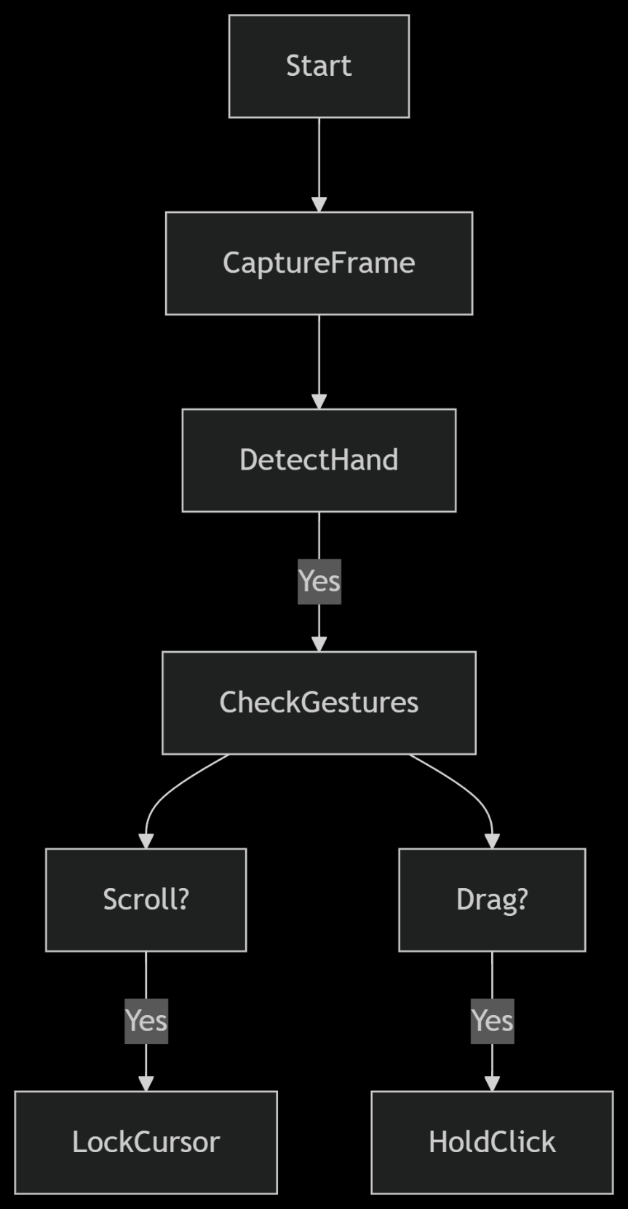

5.2 Data Flow Diagram (DFD)

The DFD shows data flow from the webcam to hand tracking, gesture processing, mouse control, and screen output.

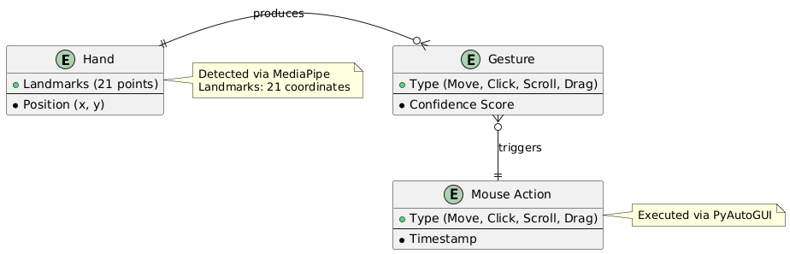
5.3 Entity-Relationship Diagram (ERD)
The ERD depicts relationships between entities: Hand, Gesture, and Mouse Action, as the system has no database.

5.4 Use Case Diagram
The use case diagram outlines user interactions with the system: moving the cursor, clicking, scrolling, and dragging.
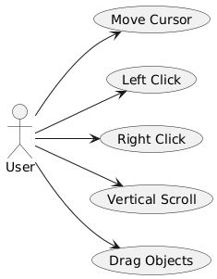
CHAPTER 6: IMPLEMENTATION

6.1 Functions Used in the Code
- get_landmarks(): Detects hand landmarks using MediaPipe and draws them on the webcam feed.
- check_fingers(): Identifies extended fingers to determine gestures (e.g., fist, two-finger).
- Mouse Movement Logic: Maps index finger position to cursor coordinates using np.interp().
- Click Detection: Detects pinch gestures for left/right clicks using np.hypot().
- Scroll Logic: Calculates scroll direction based on two-finger movement.
- Drag-and-Drop Logic: Initiates drag with a fist gesture, releases on open hand.

6.2 Interface Screenshots
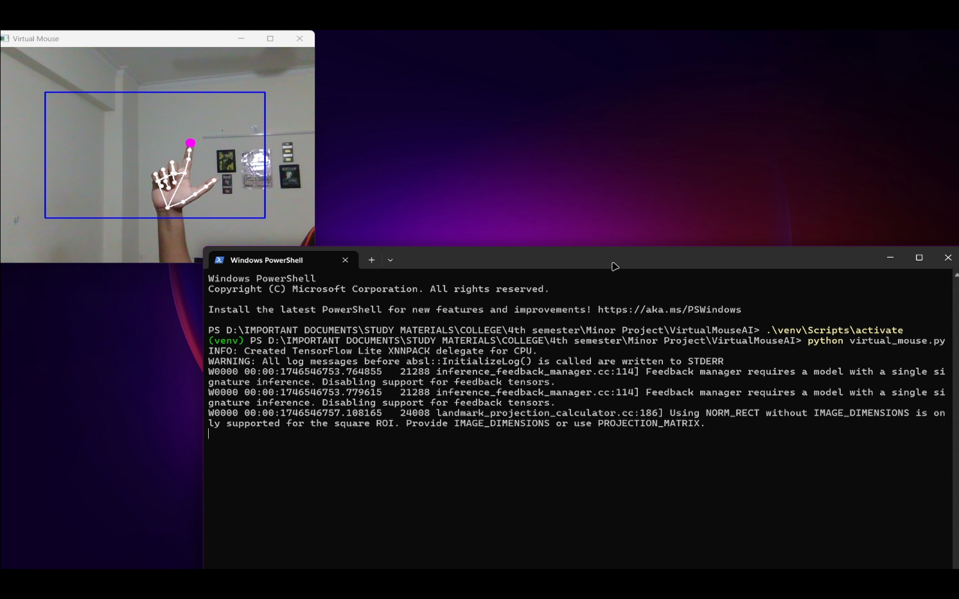
Fig. 1 - Cursor Movement Window

- Description: Webcam feed showing hand landmarks, index finger raised, cursor movement active, with a pink circle on the index finger.

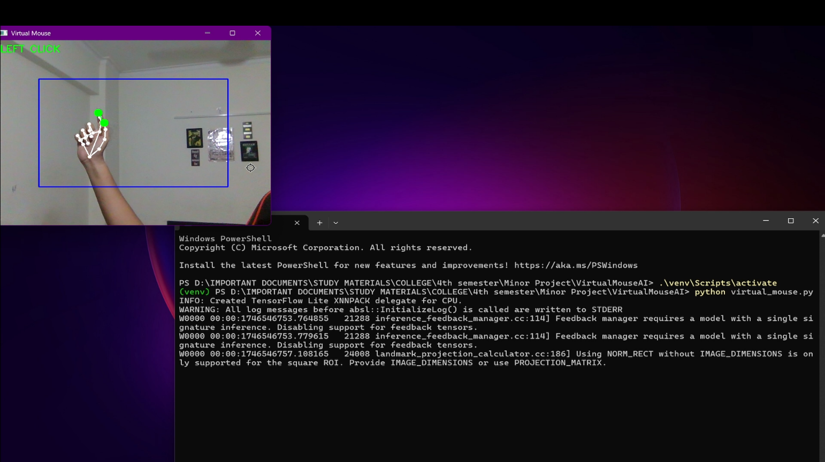
Fig. 2 - Left Click Detection

- Description: Feed during a left click, showing “LEFT CLICK” text, green circles on thumb and index finger, and a connecting line.
Fig. 3 - Scrolling Interface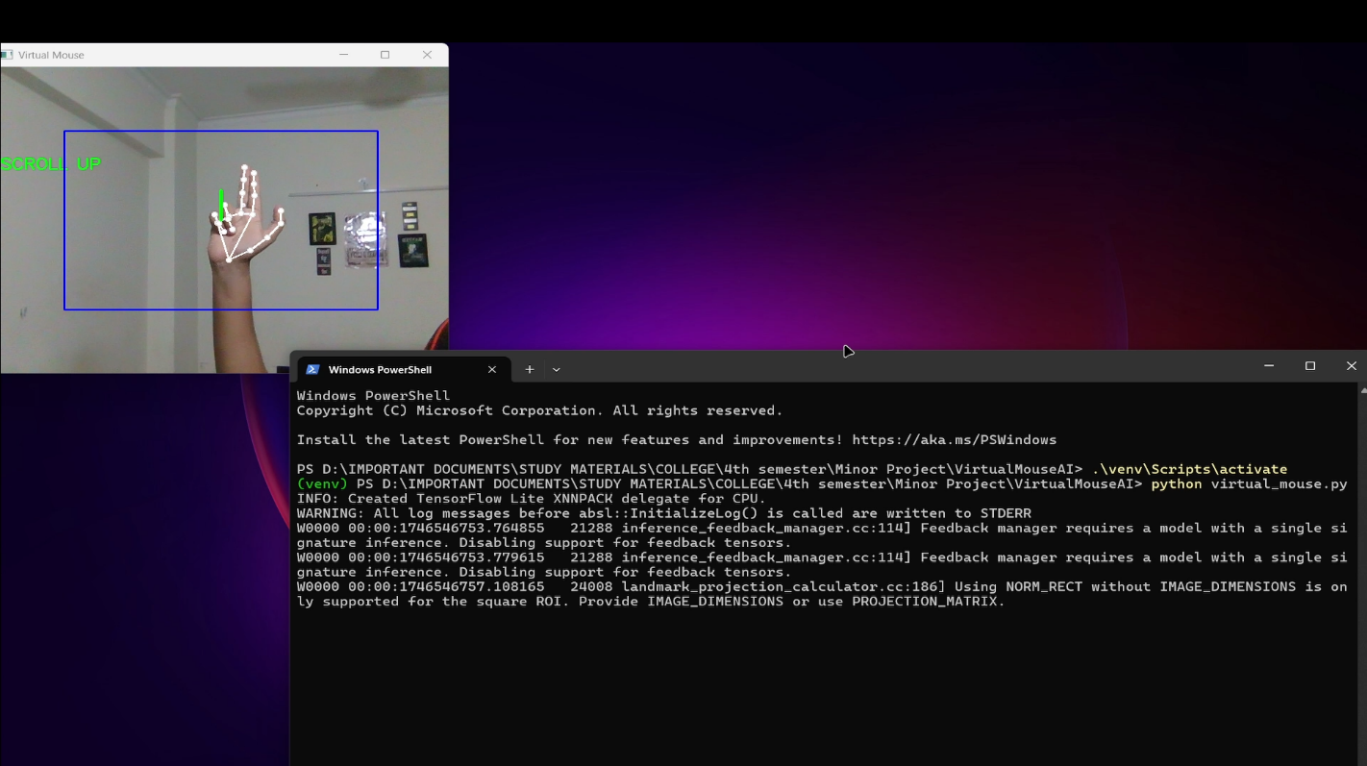
- Description: Feed during scrolling, showing “SCROLL UP” text, two-finger gesture, and a green line indicating scroll direction.
CHAPTER 7: CONCLUSION, LIMITATIONS, AND FUTURE SCOPE
7.1 Conclusion
- Successfully implements a gesture-based virtual mouse with comprehensive features.
- Enhances accessibility for users with disabilities through contactless interaction.
7.2 Limitations
- Limited to single-hand detection, restricting multi-hand gestures.
- Requires consistent lighting (100–1000 lux) for reliable tracking.
- Performance may degrade on low-end hardware.
7.3 Future Scope
- Support for multi-hand gestures to enable complex interactions.
- Optimization for low-end hardware to broaden accessibility.
- Cross-platform support for Linux and macOS.
- Integration of voice commands for enhanced control.

REFERENCES
- Saeed, N. (2020). Hand Gesture Controlled Mouse Cursor with OpenCV and MediaPipe. Medium. https://medium.com/@611noorsaeed/hand-gesture-controlled-mouse-cursor
- HxnDev. (2022). Virtual-Mouse-using-OpenCV. GitHub. https://github.com/HxnDev/Virtual-Mouse-using-OpenCV
- GeeksforGeeks. (2023). Real-Time AI Virtual Mouse System Using Computer Vision. https://www.geeksforgeeks.org/ai-virtual-mouse/
- OpenCV Documentation. (2023). https://docs.opencv.org/
- MediaPipe Documentation. (2023). https://google.github.io/mediapipe/
- PyAutoGUI Documentation. (2023). https://pyautogui.readthedocs.io/

